**DELTA Module 1**

**Application Form**

## PERSONAL DETAILS

|  |  |  |  |
| --- | --- | --- | --- |
| **Family Name** |  | **Given Name** |  |
| **Date of Birth** | DD/MM/YY | **Nationality** |  |
| **Landline** |  | **Mobile** |  |
| **Email** |  | **Skype Address** |  |
| **Do you use Zoom?** | Yes / No | **Present Occupation** |  |
| **Address** |  | | |

## NON-ELT QUALIFICATIONS

(An under-graduate degree in any field is expected.)

|  |  |  |  |  |
| --- | --- | --- | --- | --- |
| **Qualification** | **Institute** | **Subject/s** | **Grade**  **(if relevant)** | **Date Obtained** |
| *e.g. BA* | *University of Toronto* | *History, Politics* | *NA* | *Jun 2005* |
|  |  |  |  |  |
|  |  |  |  |  |
|  |  |  |  |  |

**KNOWLEDGE OF LANGUAGES AND LEVEL OF ABILITY**

(Include your English ability here using CEFR or IELTS – evidence may be requested. Indicate your L1.)

|  |  |
| --- | --- |
| **Language** | **Ability** |
| *e.g. English* | *IELTS 8* |
| *e.g. Arabic* | *L1 / Fluent* |
| *e.g. French* | *Pre-Intermediate / A2* |
|  |  |

**EXPERIENCE IN TEACHING ENGLISH TO SPEAKERS OF OTHER LANGUAGES**

(A minimum of two years full-time teaching experience is the norm for Delta Applicants.)

|  |  |  |
| --- | --- | --- |
| **Dates** | **Institute** | **Role / Responsibilities** |
| *e.g. 2015-2020* | *Sheikh Zayed University, Abu Dhabi* | *EAP Tutor* |
| *e.g. 2010-2015* | *British Council, Cairo* | *General English, EAP, Exams, YLs* |
| *e.g. 2008-2010* | *IH Vancouver* | *General English, YLs* |
|  |  |  |

## 

## OTHER RELEVANT WORK EXPERIENCE

|  |  |  |
| --- | --- | --- |
| **Dates** | **Institute** | **Role / Responsibilities** |
| *e.g. 2006-2007* | *VSA, Uganda* | *Volunteer teacher aide in primary schools* |
|  |  |  |
|  |  |  |
|  |  |  |

## REFERENCES

Please provide two referees should we wish to follow up your application

|  |  |  |
| --- | --- | --- |
| **Name** | **Relation to You** | **Email** |
| *e.g. John Smith* | *Current HOD Zayed University, Abu Dhabi* | *JohnSmith@zayed.ae* |
| *e.g. Maryam Ali* | *Was my Senior Teacher, BC Cairo 2014* | *Maryamali@outlook.com* |

## 

**Delta Module 1**

**Pre-Interview Tasks**

The following tasks are designed to:

(1) expose you to the level of understanding required of you as a foundation for the course and

(2) assess existing knowledge and abilities

**Task 1:**

**provide the term for each definition:**

1. A test that consists of factual questions requiring one correct answer that can be quickly and unambiguously scored by anyone with an answer key. For instance, MCQs and true or false questions.
2. The verbal signals given by the speakers to indicate interest, attention, surprise etc. (e.g., well, you know, actually).
3. A time limited activity in which students work in pairs (one student sits and one student runs) to accurately write down a single text, words, sentences, or questions that are spread around the classroom, as quickly as they can.

**Task 2:**

**Provide a definition and an appropriate brief example or illustration for the terms below:**

1. Prominence.

…………………………………………………………………………………………………….

1. Present participle.

………………………………………………………………………………………….…………

1. Referent pronouns.

…………………………………………………………………………………………………….

**Task 3:**

**The extract for this activity is the writing task below for pre-intermediate (CEFR B1) level learners.**

**Your English teacher has asked you to write the introduction and the first body paragraph essay.**

**The question is as follows:**

|  |
| --- |
| Global warming is one of the most serious issues that the world is facing today.  What are the causes of global warming? |

Focusing on the areas listed below, identify a total of four key strengths and weaknesses of the pragraph. Provide an example from the text of each choice. Include at least two strengths and weaknesses of the text. Provide an example from the text of each choice. Include at least one strength and one weakness in your answer.

**Task achievement.**

**Cohesion.**

**Accuracy of grammar.**

**Accuracy of lexis.**

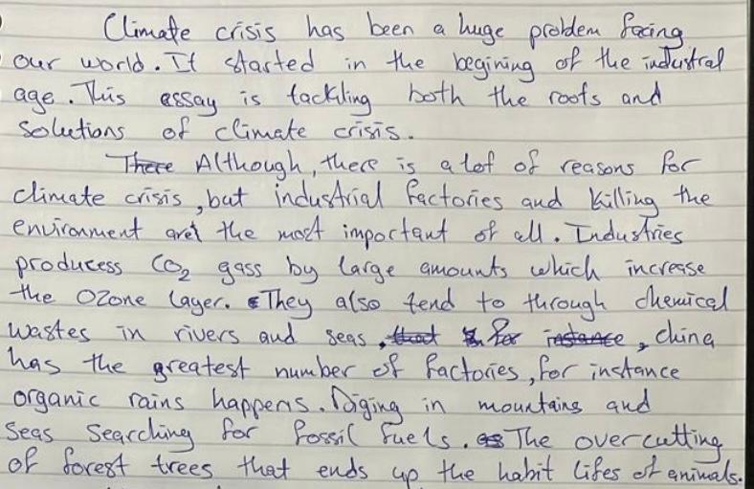

**Task 4 –**

**The extract for this task is the speaking activity below for upper-intermediate (B2 CEFR) learners.**

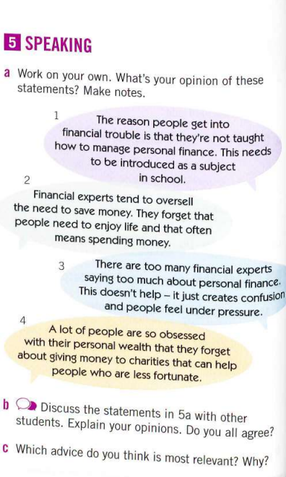

In order to complete this activity successfully, learners at this level need to use the following key language features:

* Lexis-related topic given in the task. Example

Identify a total of three further language features learners at this level would need to use to complete this task, provide an example specific to this activity to support each choice.

**Task 5 – Task 5: Comment on the form and use of the words in bold**

* Our **class** took a field trip to the natural history museum.
* We enjoyed a delicious **home-cooked** meal.
* I **had** my car **fixed.**
* I **am travelling** tomorrow.